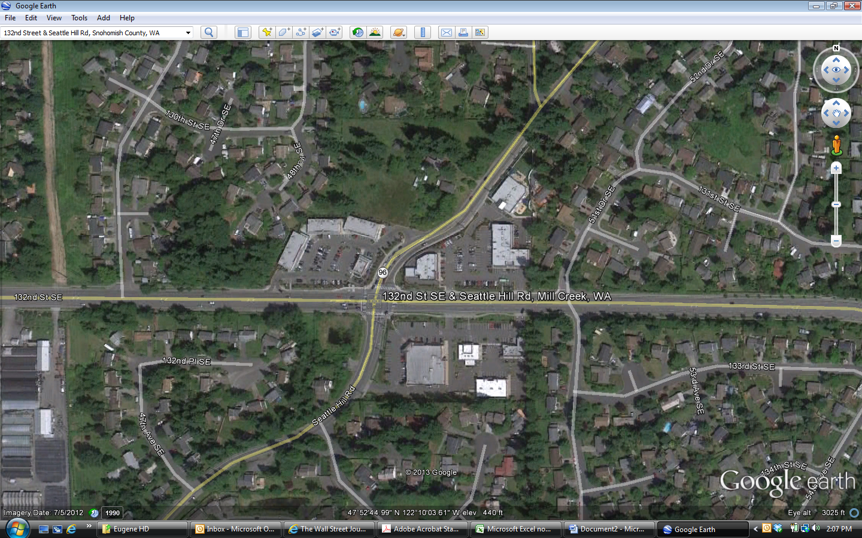

***Osborne Square***

Starbuck’s

Allstate

H & R Block

Desert Sun

Chase Bank

Bartell’s Drug

Whidbey Island Bank

Pizza Hut